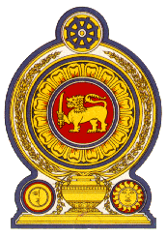

44th Session of the Universal Periodic Review

**Review of Germany** – 9th November 2023

Statement by the Democratic Socialist Republic of Sri Lanka

Mr. President,

Sri Lanka warmly welcomes the delegation of Germany and appreciates the presentation made.

Sri Lanka commends the measures taken by Germany since its last UPR towards strengthening the respect for human rights and taking account of the interests and needs of young people through its youth strategy as well as initiatives to widen the scope for participation of young people by 2025 by means of a National Action Plan for Child and Youth Participation.

In a constructive spirit, Sri Lanka recommends that Germany;

1. Ratify the International Convention on the Protection of the Rights of All Migrant Workers and Members of Their Families.
2. Continues to tackle and address racism and racial discrimination at all levels of society through executive, legislative and judicial action and in dialogue with civil society.
3. Continues efforts to promote the reconciliation of work and family life of persons by ensuring childcare and family friendly working environments for parents to achieve a good work-life balance.

We wish Germany success in its UPR engagement.